Ben Reynolds – 13309656

## Slot Machine – Sample Runs

## Sample Run One:

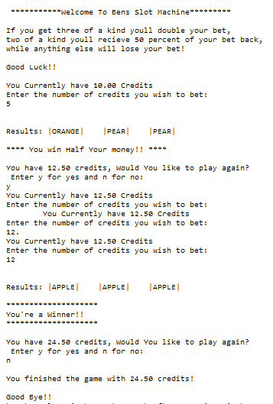

## Sample Run Two:

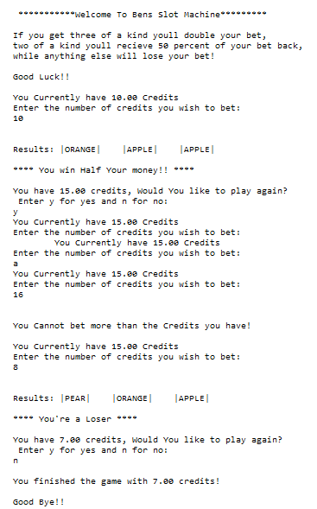

### Sample Run three:

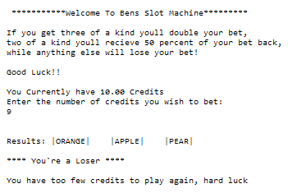

## Sample Run Four:

